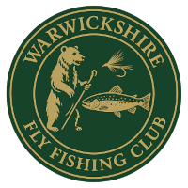

WARWICKSHIRE FLY FISHING CLUB APPLICATION FORM

WFF Sponsors Name: (If applicable) Membership No.

I wish to be considered for:

Full / Catch & Release / Limited visits / Junior. (Please circle your choice.)

Full Name: DOB:

Address:

Post Code:

Telephone number including code:

Email address:

Occupation:

I am a member of the following Angling Clubs/Associations:
I have an EA Fishing license: Yes / No
Where did you hear about Warwickshire Fly Fishers?
If accepted for membership I agree to abide by the Constitution and Rules of the Club.
I understand my details will be kept on a Computer Data Base for the sole use of
Warwickshire Fly Fishers.

Signed: …………………………………………. Date:

Please email this form complete with your passport sized photograph to:
membership@warwickshireflyfishers.org
Payment methods will be advised once accepted as a member.

For Club use only:
Accepted YES/NO
Membership Number : Membership List Email Group: Yes / No
Membership Book Photograph
Subscription Paid : Yes / No
Site Visit: Yes / TBA.

